IMPLEMENTATION OF SET-RESET FLIP-FLOP USING STOCHASTIC RESONANCE

K. Murali^{1*}, William L. Ditto¹ and Sudeshna Sinha²
¹Department of Biomedical Engineering, University of Florida, Gainesville, FL32611-6131, USA
²The Institute of Mathematical Sciences, Taramani, Chennai – 600 036, INDIA

Abstract— In this letter, we introduce a scheme to construct SR flip-flop implementation using the dynamical phenomena of stochastic resonance. The idea is to exploit the effect of noise on nonlinear systems in order to extract different desired responses from it. We explicitly demonstrate the principle by implementing the fundamental NOR gate, both experimentally and numerically. Further stochastic resonance based SR flip-flop can be implemented from two cross-coupled NOR gates to demonstrate the efficacy of this approach to construct sequential gate architectures.

*On leave from Department of Physics, Anna University, Chennai – 600 025, INDIA

- Introduction

Recentely, there has been a new theoretical direction in harnessing the richness of nonlinear dyanamics, namely the exploitation of chaos to do flexible computations [Sinha & Ditto, 1998; Munakata et al., 2002; Murali et al., 2003, Cafagna & Grassi, 2006; Murali & Sinha, 2007; Ditto et al., 2008]. In this letter we propose a very different scheme to implement fundamental logic gate structures: We will exploit the dynamical phenomenon of stochastic resonance in nonlinear systems. The phenomena of stochastic resonance (SR) has received much attention over the past few decades [Bulsara & Gammaitoni, 1996; Gammaitoni et al., 1998;1999], and can generally be considered as the phenomena whereby weak input information (such as a very weak signal) can be amplified and optimized under noise that is inherent in the system or that adds to the input. We exploit this simple, roubst and rather well understood principle, to do a hitherto unexplored task, namely to construct logic gate architectures. Presently, first we will show the feasibility of constructing noise-assisted logic gates by explicitly implementing the fundamental NOR gate. A system is capable of universal general purpose computing if it can emulate a NOR gate, since the basic logic operations, AND, OR, NOT, XOR and NAND, can be constructed by combining the NOR operations [Mano, 1991]. Further, we will demonstrate the efficacy of this gate implementation, to realize a new stochastic resonance based sequential gate, namely SR flip-flop circuitry obtained from two cross-coupled NOR gates.

- Scheme for obtaining the basic NOR gate with a system with stochastic resonance

Consider a logic cell here is comprised of a nonlinear system, represented by:

$\overset{˙}{x}=F(x)+I+Dη(t),$ (1)

where F(x) is a nonlinear function giving rise to a double-well potential (with the wells centered around x₊ and x₋). I is a low amplitude input signal, and $η(t)$ is an additive zero-mean Gaussian noise with variance 1. The parameter D fixes the noise strength. Such a system typically is capable of displaying SR, with the state switching between the two wells x₊ and x₋. The inputs determine the low amplitude signal I in Eqn.(1)(see Schematic in Fig.1). For instance for 2-input gates: I = I₁ + I₂, where I₁ and I₂ encode the two logic inputs. The logic output will be given as follows:
- If x > 0, Logic output is 0 and (ii) If x < 0, Logic output is 1.

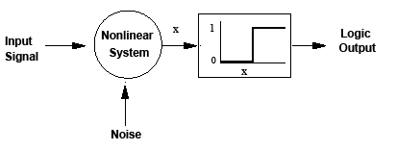

FIG.1. Schematic diagram of a logic cell comprised of a nonlinear system forced by an input signal and

noise.

The important point is that one can extract a robust and consistent logic output from this nonlinear system represented by Eqn.(1). Now for a NOR gate implementation the following must hold true: (i) I₁ = 0 and I₂ = 0: output is 1; (ii) when I₁ = 0 and I₂ = 1 or I₁ = 1 and I₂ = 0: output is 0; and (iii) when I₁ = I₂ = 1: output = 0. In order to design the NOR gate, one has to use an optimal noise level. That is, for very small noise the system does not yield the requisite response. Obviously when noise is too high the responses will be error-prone again. In a reasonably wide window of moderate noise, the system yields the correct responses that will satisfy and yield the above input-output association.
Now we explicitly demonstrate the general idea above with a simple system that shows stochastic resonance. The system we propose to use as the basic logic cell has the advantage that the only nonlinearity in the system is implemented by a simple thresholding mechanism.
Specifically, under additive noise of amplitude D, it is given be:
$\overset{˙}{x}=−αx+βg(x)+I+Dη(t),$ (2)
The nonlinear function g(x) is a piecewise-linear function that is particularly easy to implement:
g(x) = x when ≤ x ≤
g(x) = when x < (3)
g(x) = when x >

where and are upper and lower thresholds respectively. An advantage of this piecewise-linear function is that it can be realized by an extremely simple experimental circuit. The response of this system under varying noise amplitudes, both additive and multiplicative, display enhanced response in a window of moderate D value.
The stochastic resonance in this system can be clearly understood if one inspects the effective potential generated by the thresholding (see Fig. 2). The effective potential is a double-well, a scenario where SR is very well elucidated [3]. The position of the wells are give by x₋ = (${{βx}_{l}^{}}/α$) and x₊ = ${{βx}_{u}^{}}/α$. So the heights and asymmetry of the wells can be manipulated very easily by simply setting different thresholds . Characteristic signatures of SR are observed in this system, e.g. in the dependence of the SNR on noise level D [Bulsara & Gammaitoni, 1996].
With this system now, one can implement NOR logic gate, by following the general schemes outlined earlier. Specifically, in Eqn.(2), we take α = 1.8, β = 3.0, =1.55, = -1.0 and the two inputs I₁ and I₂ take value -0.4 when logic input is 0 and value 0.4 when logic input is 1. Fig. 4 shows the dynamics of the system under different noise levels D. The remarkable thing here is that noise helps to select the desired responses from this nonlinear system. In a reasonably wide window of moderate noise, the system yields the correct robust NOR logic response. Obviously when noise is too high the response will be error-prone.

- Stochastic resonance based SR flip-flop
In this section, we elucidate the implementation details of two cross-coupling between the NOR gates synthesized through stochastic resonance to emulate SR flip-flop. The general schematic for a typical NOR gate based SR flip-flop implementation and the corresponding truth table are given in Fig.3(a) and 3(b) respectively . The time waveforms of the implemented SR flip-flop are depicted in Fig. 4. The efficacy of this scheme is that noise helps to select the desired responses from this coupled nonlinear systems to realize a new stochastic resonance based sequential logic gate.
Further, proof-of-principle experiments have also been carried out with suitable analog simulation circuits, and the results are in complete agreement with our presently discussed numerical simulations results and PSPICE simulations of the electronic analog of Eqn.(2).

- Summary and conclusions

In summary, we have used a new physical principle for an ubiquitous applications. Namely,

we have proposed the use of the dynamical phenomena of stochastic resonance in nonlinear systems for the design of key NOR gate structure. We have demonstrated the idea explicitly using a piecewise-linear system, that has a particularly simple experimental realization. Thus we provide a proof-of-principle experiment of the capability of stochastic resonance systems for universal computing. Most importantly, one is able to construct a new stochastic resonance based sequential gate structure, namely SR flip-flop obtained through two cross-coupled NOR gates. So the methodology described here is universal and robust in that it allows realization of general purpose computer architecture based on the interplay between noise effect and functionality of nonlinear system.

References
Bulsara, A.R. & Gammaitoni, L. [1996] “Tuning in to noise”, Physics Today 49, 39-45.
Cafagna. D. & Grassi. G. [2006] “Chaos based SR flip-flop via Chua’s circuit”, Int. J. Bifurc. Chaos
16, 1521-1526.
Ditto. W.L., Murali, K., & Sinha S. [2008] “Chaos computing: ideas and implementations”, Phil.
Trans.R.Soc.A 366, 653-664.
Gammaitoni, L., Hanggi. P., Jung. P. & Marchesoni, F. [1998] “ Stochastic resonance”,
Rev.Mod.Phys. 70, 223.
Gammoitoni, L.,et al., [1999] “Controlling stochastic resonance”, Phys.Rev.Lett. 82, 2863.
Mano, M.M., [1991] Computer System Architecture and Logic Design (Mc-Graw
Hill, New York).
Murali. K.,& Sinha, S. [2007] “Using synchronization to obtain dynamic logic gates”, Phys.Rev.E
75 025201 (R).
Murali, K., Sinha. S. & Ditto.W.L., [2003] “Implementation of NOR gate by a chaotic Chua’s
circuit”, Int. J. Bifurc. Chaos 13, 2669-2672.
Munakata, T., Sinha S. & Ditto, W.L. [2002] “Chaos computing: Implementation of fundamental
logic gates by chaotic elements”, IEEE Trans.Circ.Systems 49, 1629.
Zaikin, A.A., Murali. K., & Kurths, J. [2001] “Simple electronic circuit model for doubly stochastic
resonance”, Phys.Rev.E 63, 020103 (R).

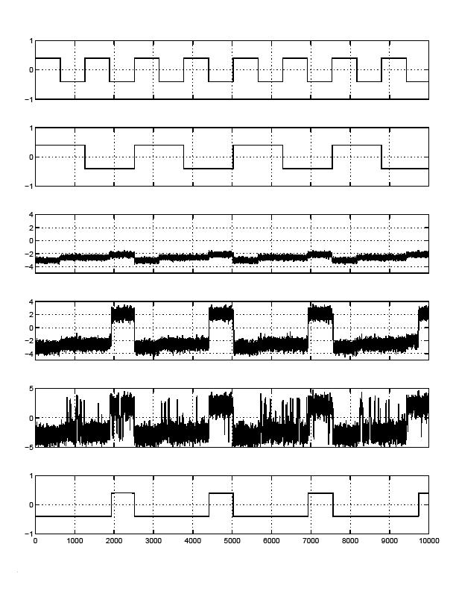

Fig.2. Simulation results of Eqn.(2). Timing sequences from top to bottom: (a) First input I₁, (b) Second input I₂, (c) Output –x(t) for D=1.0, (d) Output –x(t) for D=2.35, (e) Output –x(t) for D=4.0, (f) Recovered output NOR (I₁, I₂) from (d).

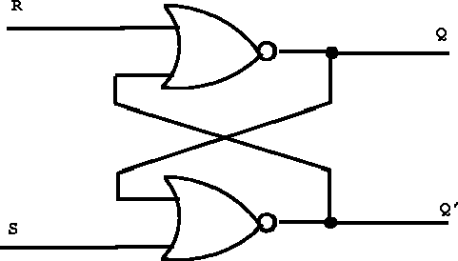

Fig.3(a). SR flip-flop using two cross-coupled NOR gates

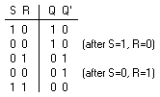

Fig.3(b). Binary truth table for SR flip-flop.

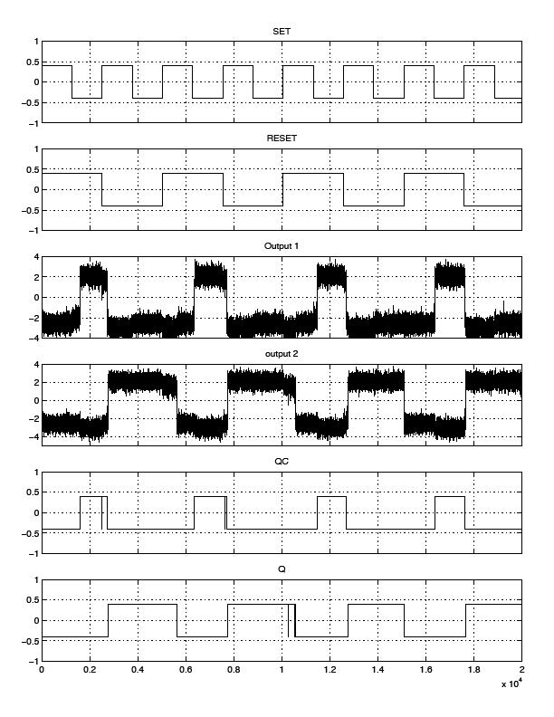

Fig.4. Timing sequences from top to bottom: (a) Input Set, (b) Input Reset, (c) Output –x(t) from first NOR gate (d) Output –x(t) from second NOR gate , (e) Recovered Conjugate output Q_{c}, (f) Recovered Output Q. Here the noise intensity D=2.35.

