Space diary

FAR SIDE
by
Kamal Lodaya

The Moon goes around the Earth in about a month (the words “moon” and “month” are related), 29 and a half days from new moon to new moon. It has phases, from new moon to crescent to half moon to gibbous and back the same way to new moon. As it goes through the phases, more and more of its face gets uncovered, and on full moon we can see the “rabbit” formed by the dark areas on its surface. The Italian scientist Galileo Galilei thought these were “seas”. Today we know that they are plains. The less dark areas are rougher, reflecting more sunlight.
The fact that some parts of the Earth are closer to the Moon than others, because they are directly under it, gives rise to tides. The water in the oceans rises higher as it is pulled towards the Moon in some places. In other places the water that is pulled away elsewhere makes it a low tide at the same time.
If the Moon's gravity has so much effect on our oceans, imagine what the effect of the Earth's gravity on the Moon would be. The Earth is four times the diameter of the Moon, and weighs a lot more. How come we do not see the effects of the earthly tides on the Moon? The answer is, yes we can. The effects lie in the simple fact that from new moon to full moon, we always see the same face of the Moon, the one with the rabbit. The Moon's rotation also takes one month, because the earthly tides are so powerful that they have locked its rotation period.
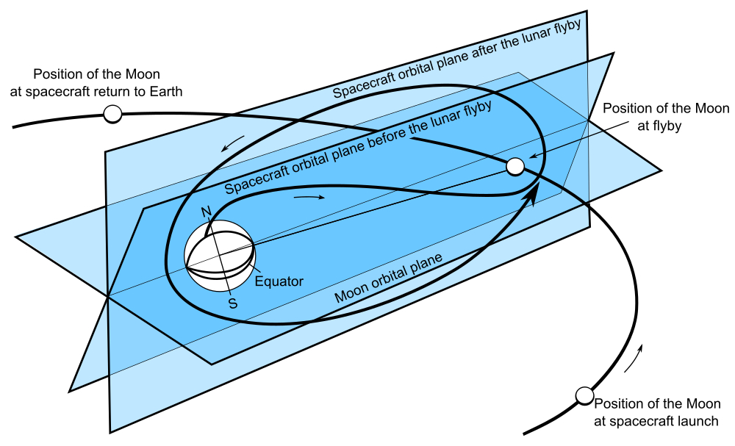
The dark side of the Moon
The Moon is a sphere, so it does have another side, but it is always away from us, It was first seen by the Russian spacecraft Luna 3 in 1959, which went all the way around the Moon six decades ago. Luna 3 found that the far side of the Moon is more rocky than the one we see, it has fewer plains and more mountains. Although it flew over the Moon's south pole to reach the far side, Luna 3 used the gravity of the Moon to change its path and arrive back over the northern hemisphere of the Earth (where Russia is). This calculation using the equations of Isaac Newton was done by Mstislav Keldysh at the Steklov Institute of Mathematics. He was known as the “chief theoretician” of the Russian space programme in those days. Unfortunately the spacecraft did not survive our own atmosphere. Contact was lost and Luna 3 is believed to have burned up in the atmosphere.
Ever since Luna 3, people have thought of using the far side of the Moon. Since the bright Earth is never visible from that side, and there is no atmosphere to speak of on the Moon, even a moderate-sized telescope could yield a spectacular view of the stars.
The difficulty is, even if we set up such a telescope, who could use it? Having humans living on the airless Moon would be hugely expensive. India has a telescope at Hanle in Ladakh, used by astronomers from all over India, operated largely using computers. Couldn't we have such an automated telescope on the Moon?
How would we operate it? Even if we pre-programmed all that it had to do, how would we get back the pictures it took? The data cannot be sent because the far side is the far side, we cannot ever see it! This is why no humans have landed on the far side of the Moon. It would be too risky for them to be out of contact with the Earth for a large amount of time.
Chang'e-4
The solution to this problem was found by China. On 3rd January this year, they landed an automated spacecraft Chang'e-4 on the far side of the Moon. (Chang'e is a moon goddess in China.) After landing it unrolled a ramp and an automated rover Yutu-2 rolled down the ramp to the surface of the Moon. The name stands for “jade rabbit”. Now the rover is going to go around taking pictures and sending them back to us.
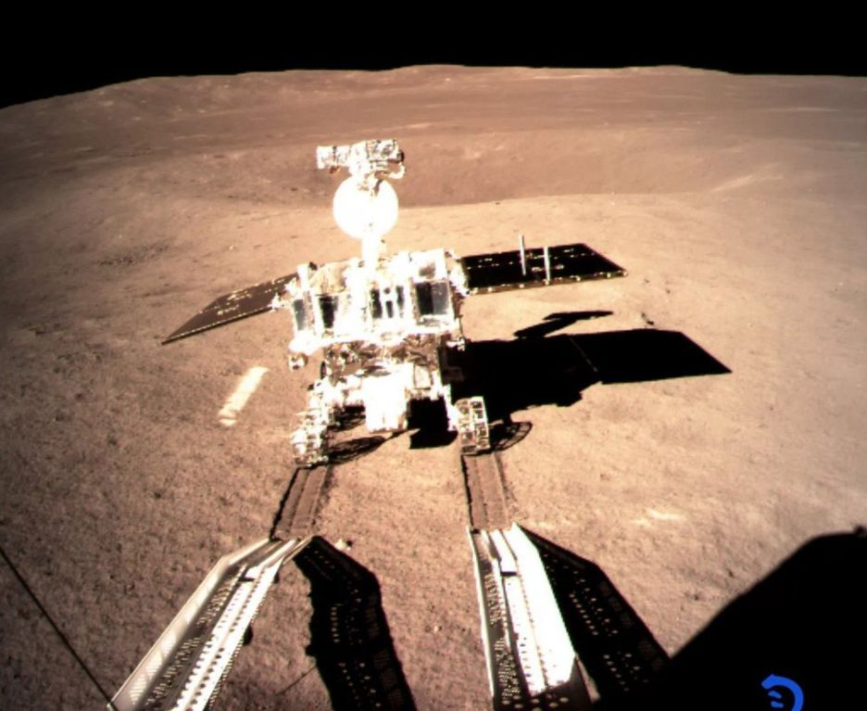
Lagrange point L2
But how can it beam these pictures back to us? China had first sent its Yutu 1 rover to the side of the Moon that we can see, so that it could try out the rover technology and send us pictures. But how to send pictures from the far side? This required some preparation and we have to take a flashback to May 2018.
On the Moon we have the Moon's gravity. It is one-sixth of what we find on the Earth but it is the Moon's gravity which holds Yutu there, it does not fly off into space. As we rise from the Moon's surface and fly out, its gravity becomes less and less, until we reach a point 65,000 km from the Moon (remember the Moon is already about 4 lakh km from the Earth). This point has a name, it is called the Lagrange point L2. Here the Moon's gravitational attraction is the same as the Earth's gravitational attraction, even though the Earth is farther, because Earth has more mass. If we put a spacecraft there, it would stay there, neither would it fall on the Moon, nor on the Earth. And from there you can see both the far side of the Moon and the Earth.
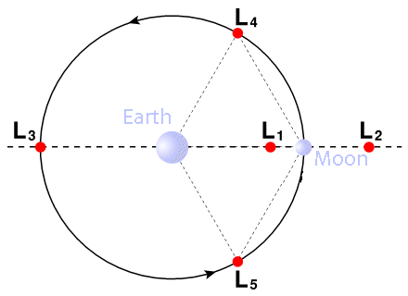
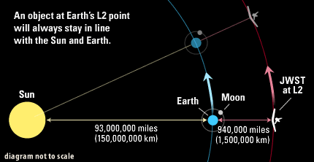
To go off on a tangent, this should suggest to you that there is another such point, the Lagrange point L1. Can you think of where this might be? The European mathematicians Leonhard Euler and Joseph-Louis Lagrange studied these kinds of points in the 18th century.)Pictures from the L2 point was taken by the Queqiao spacecraft, which reached the L2 point in June 2018. The picture of Earthrise over the Moon is by the Longjiang 2 satellite. It shows a crater on the far side. The name “Longjiang” name means Dragon river. This satellite was put into lunar orbit by the Queqiao spacecraft; the name means "Magpie bridge". Getting a spacecraft to L2 was difficult. The picture shows the complicated path taken by it.
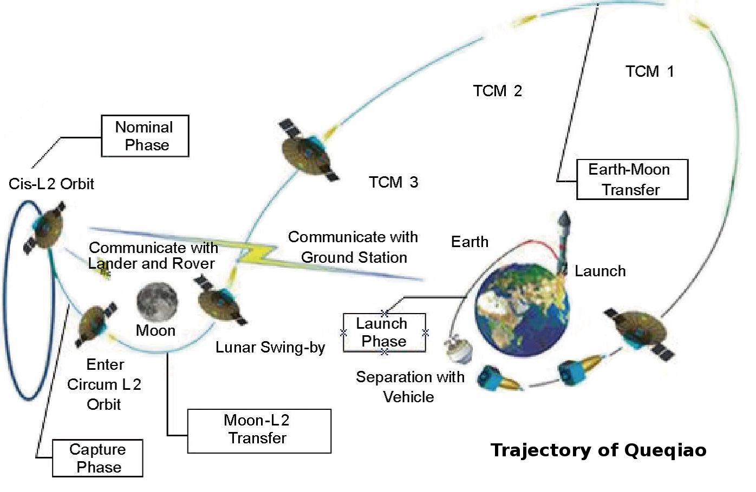
To get back to our problem, Yutu talks to Chang'e. Chang'e talks to Longjiang. Longjiang talks to Queqiao. (Actually both Yutu and Chang'e can directly talk to Queqiao.) Queqiao talks to Earth. Just as we in India can talk to people, elsewhere in India or in China or in America, using a communications network which includes satellites in space above the Earth, the Chinese have their communications network set up for the far side of the Moon.
Meanwhile Chang'e is not sitting idle. There are many interesting experiments on it. One designed by Chinese universities is to try and grow potatoes, tomatoes, a flowering plant and silkworms, by providing in a box a small Earth-like atmosphere. But of course this life has to live in lunar gravity, not Earth's gravity.

