Coastlines and global warming
D. Maya, Kolkata
BOX 1

I grew up in Chennai, near the coast. I always loved to see the sea, its changing colours and levels. When I was young, I was scared of the high waves at high tide. But it was fun to “run away” from big waves and see if you could outrun it. In any case, for me the ocean always meant loud breaking waves and golden sands. My sister and I would always comment on the tide level and how big or small the beach was, because of the falling or rising tides.
Later on, when I learned about global warming and climate change, it still did not occur to me that it could affect my coast. It had remained unchanged through my entire childhood and young adult life. Whenever I came back to Chennai, it would be there to greet me, looking the same as before: or changing the same as before.
Recently, though, I read an article about how sea levels were rising very fast near Kolkata, where I now live. It seems that sea levels are rising 15 times faster at at Diamond Harbour in the Sundarban areas of West Bengal compared to Mumbai. However, sea levels are rising everywhere across India, and much of the world. Here is an article about it.
END OF BOX 1
Why is the sea level rising?
Sea levels are rising due to global warming that has caused the climate to change. One reason is that warm water has a lower density than cooler water (see Box). Since the density is defined as the mass per unit volume, smaller density means the same mass of water now occupies a larger volume. So warm water expands and occupies more space, leading to rising sea levels.
BOX 2 Sinking or floating
We have all seen that ice floats on water. In fact, giant icebergs are known to float in the oceans, and one of them sank the famous ship, the Titanic. Both ice and water are made up of molecules of H₂O. Ice is the solid form of water. Normally, you expect solids to sink, but ice floats on water. Why does this happen?
The density of an object decides whether that object will sink or float: if it is less dense than the fluid, it will float. How high or low will it float? Archimedes found that the object will sink until it displaces a weight of fluid equal to its own weight. So a ship lies lower in water while a matchstick floats high.
Ice floats because it is about 9% less dense than water. See the figure which shows the density of water for so many different temperatures. The small figure inset into the bigger figure shows the details just around 0C, when water becomes ice (its freezing point). You can see that, actually, the density of water is maximum at 4C. Above this the density decreases, but is still more than ice, so that ice has a lower density than water at all temperatures. It is an interesting fact that ice has this low density because it is made of hexagonal crystals which give it very beautiful shapes (see the close-up picture of an ice crystal).
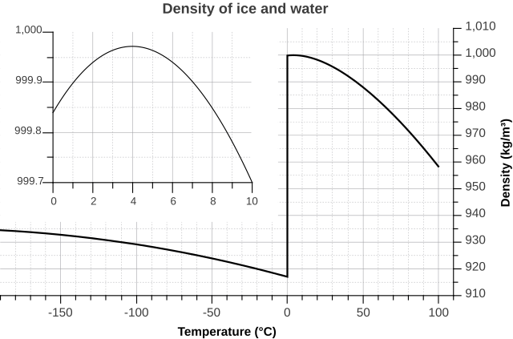

This density difference between ice and water plays a very important role for life to exist in cold seas and lakes: Even when the surface of the water has frozen, it is liquid below, so the fish and other marine life can continue to live below the surface.

Finally, as the temperature increases, the density of water keeps decreasing as you can see from the graph. That is why warmer water occupies more space (for the same mass) than colder water.
END OF BOX 2

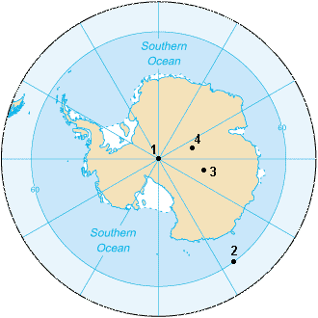
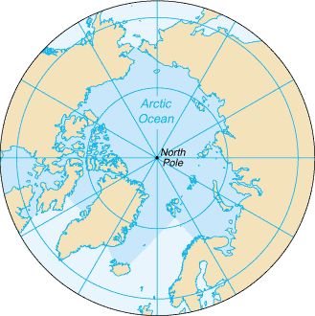
Another important reason for sea level rise is the melting of glaciers which releases more water into the sea. This is directly due to global warming. There is a difference in the contribution of glaciers on land and on the sea. The North Pole has the Arctic Ocean while there is a huge land mass, the Antarctica, at the South Pole. When ice in the Arctic melts, there is hardly any change in the sea level: think of ice in your water glass. When it melts, it does not change the water level or cause it to spill over. However, when the ice or glaciers in the Antarctic melt, the water flows into the surrounding Indian Ocean, thus raising the sea level. So melting of land ice (over Antarctic and also over Greenland near the North pole) can cause sea levels to rise.
The extent of sea level rise
Just as the Earth's surface is not flat, the surface of the ocean is also not flat, so the sea level change is different in different parts of the Earth. How much increase is there? How much more is expected? How do scientists measure this?
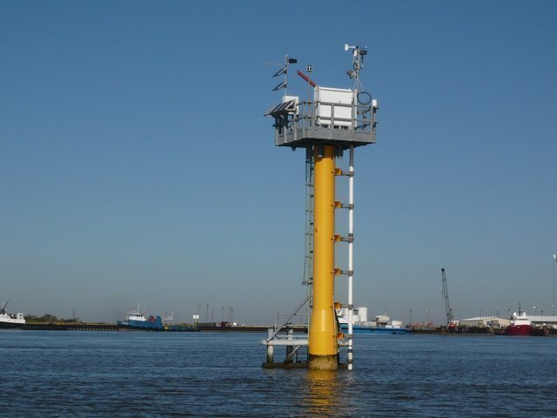
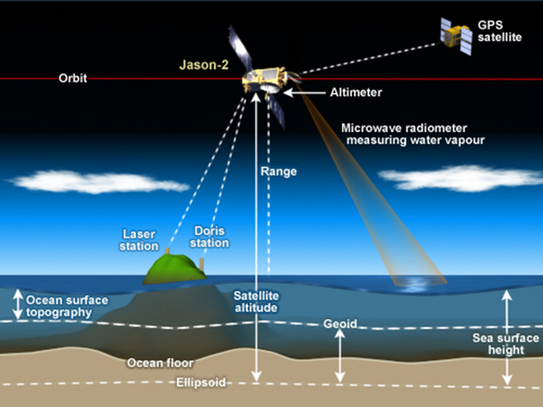
Sea level is primarily measured using tide stations and satellite laser altimeters — an altimeter measures the height or altitude of a place. Tide stations around the globe tell us what is happening at a specific place: for instance, the height of water in the sea outside Chennai compared to a fixed point of land in the interior, which will remain constant in height. Satellite measurements which are taken from distant satellites can tell us the average global height of the entire ocean. When the local and global data are taken together, these tell us that the sea levels are mostly increasing over time.
In fact, tidal records are available for over a hundred years, from 1900. On average they show that the sea level has risen by 10-12 cm in ninety years from 1900 to 1990. However the rise is not uniform over time. In the next twenty five years from 1990 to 2015, the sea has risen by an average of 8 cm, almost the same as over the previous 90 years! Satellites have been taking data since 1992 and their measurements agree with this number. This means that till 2015, the sea level has been rising by about 3 cm every decade. However, since we have not been able to cut down the emissions that result in global warming, this rate will increase even further.
Impact of sea level rise
Rising sea levels mainly impact coastal zones through multiple means. Apart from permanent submergence of land, there can be more frequent or intense coastal flooding. This can lead to change in the local ecosystem, and degradation of soil (which becomes more saline due to sea water) and water. An additional impact, especially in cities, is flooding due to poor drainage: as the sea level rises, the city's drainage system starts to become lower than the sea level and cannot efficiently let waste water into the sea.
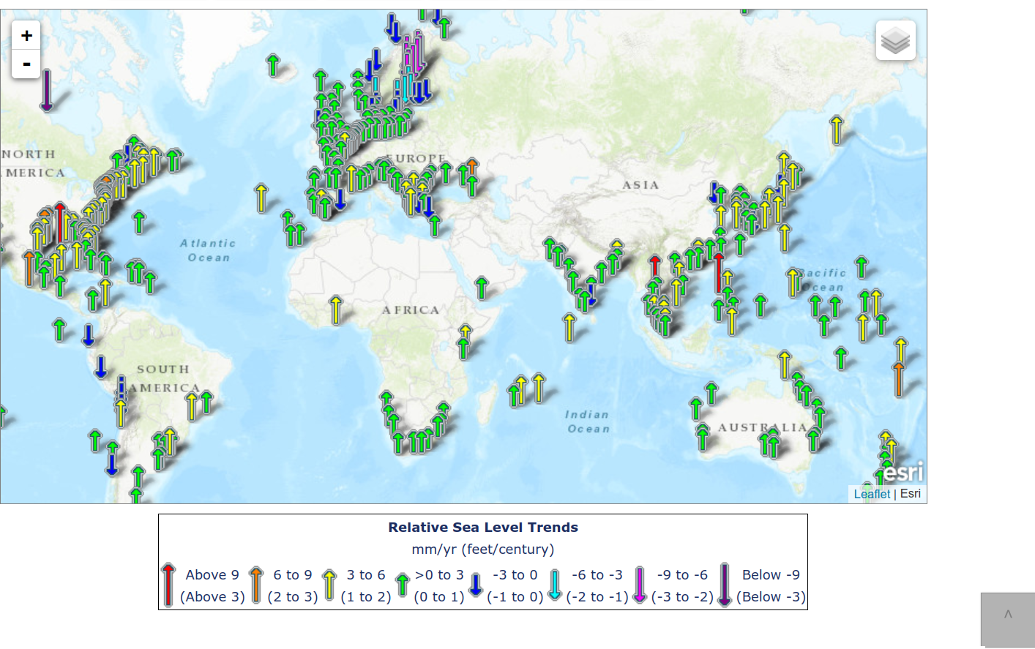
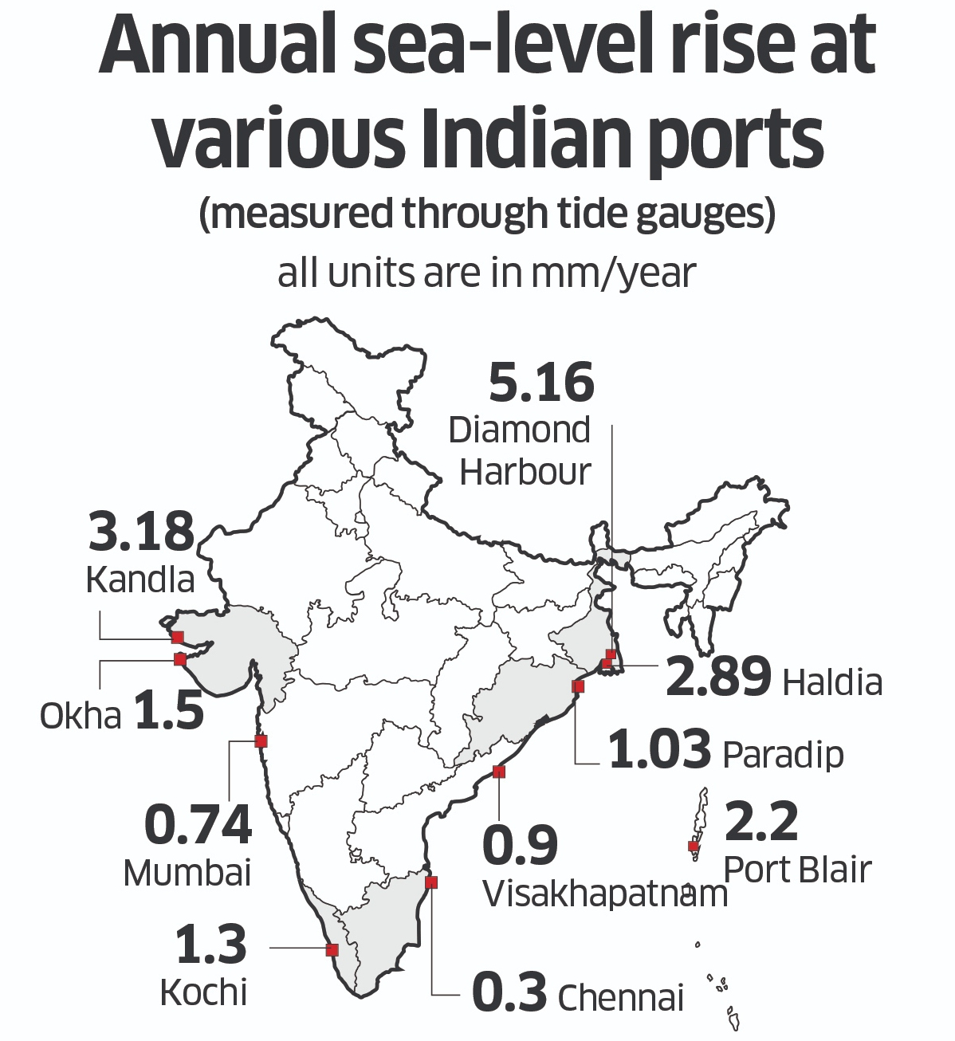
It is estimated that by the end of this century, the sea levels may increase by anywhere between 30 to 250 cm! Since Chennai is on average just 300 cm above sea level, you can see that this will make a tremendous impact on the land adjacent to its coast. Since there are also tides in the ocean, high tides can mean that several coastal buildings get indundated during high tide. The impact would be on 680 million people living in coastal areas across the world.
Indian impact
The region most vulnerable to increasing sea-level rise is the low lying coral atolls of Lakshadweep while the Karnataka coast is the least vulnerable. The east coast with a larger frequency of storms and lower continental slopes is also more vulnerable.

The map shows the coast lines that are at risk due to sea level rise. Coastal cities and mega-cities are at risk. According to the Intergovernmental Panel on Climate Change (IPCC) report of 2021, four Indian cities – Mumbai, Kolkata, Surat, and Chennai – are among 45 coastal cities where even a marginal rise would lead to flooding.
Studies done based on the IPCC report suggest that cities that will be most affected are Mumbai, Kochi, Mangalore, Chennai, Visakhapatnam, and Thiruvanathapuram. The exact extent of the sea level rise will depend on the amount by which the climate will warm up. This can also cause more intense cyclones, especially on the east coast, storm surges and exgtremely heavy rainfall events which will all have their own impact and worsen costal flooding.
From the tide gauge data maintained by Indian port authorities, the highest sea-level rise was recorded at Diamond Harbour (5.16 mm/year) in the Sundarban areas of West Bengal while the least rise was seen in Chennai (0.3 mm/year) and Mumbai (0.74 mm/year).
In Sundarbans in West Bengal, Ghoramara is the worst-affected island that lost about 50% of its landmass due to a combination of coastal erosion and sea-level rise between 1975 and 2012. It continues to be eroded even today.
How to reduce the impact
It is necessary to monitor and study extreme events (such as floods and cyclones) to prepare for efficient disaster management.
In addition, land reclamation, increasing road heights and relocation of buildings or strengthening them against damage, are all issues that can be addressed locally. But most of all, we need to address the factors that cause sea levels to rise. This is tough; but this is the only way we can preserve our heritage for generations to come.
Sources: Several, including
https://www.deccanherald.com/national/indias-coastal-cities-may-be-inundated-by-2050-report-1098840.html,
https://www.nrdc.org/experts/rob-moore/new-ipcc-report-sea-level-rise-challenges-are-growing,
https://oceanservice.noaa.gov/facts/sealevelclimate.html,
https://www.childrensmuseum.org/blog/why-does-ice-float

