**Why does the Moon not have an atmosphere?**

SK Karthick | Technion – Israel Institute of Technology, Haifa, Israel

In the last issue of ***JM***, we have seen the importance of ‘escape velocity’. This is the velocity needed by an object to escape the gravitational pull of our planet. We also showed that the escape velocity of the Moon is significantly less. Also, you may know that when meteors or external bodies in space re-enter our Earth’s atmosphere, they slow down. This is because their kinetic energy is lost due to the atmospheric drag in the form of heat. Eventually, such a high generation of heat for a significant amount of time in flight burns the body itself.

On the Moon, due to the absence of an atmosphere, passing-by meteors or external bodies crash straight into the Moon’s surface, thereby creating huge craters. We finished the last article by thanking nature for providing an atmosphere on planet Earth to counteract the continuous bombardment of meteors. In the end, we raised an important question: why does the Moon not have an atmosphere? In the present article, we will try to understand the reasons.

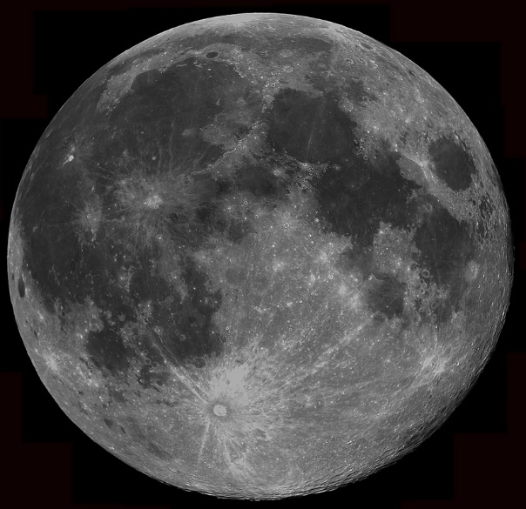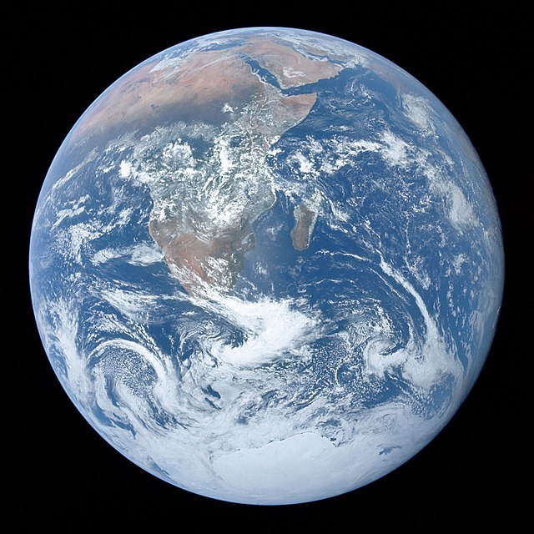

**How is the velocity of air molecules distributed?**

Air molecules are in continuous motion in our atmosphere, and they are flying everywhere. If you contain them in a box, they will continuously hit the walls of the box, elastically bounce back and interact with the other molecules and so on. The kinetic theory of gases tells us that the energy possessed by these molecules is what we perceive as temperature! We do not have to understand the detailed mathematics involved in the theory but the outcome is sufficient for the present topic. But first I have to describe what is meant by a histogram.

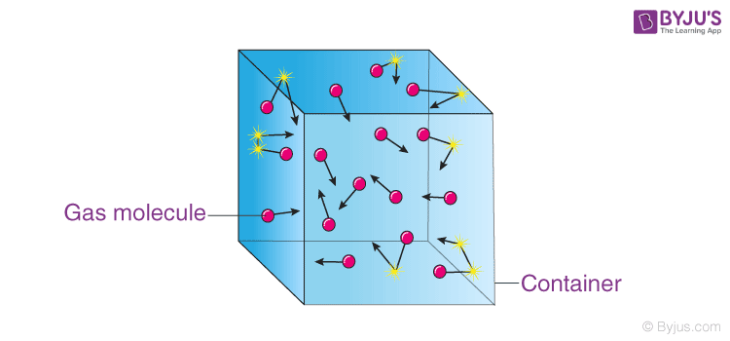

**Histograms**

You all know that, given a function y(x), you can compute y(x) for several values of x, and then plot the data points (x,y) on a graph sheet with suitable axes. Sometimes, you have thousands of data points and so it may not be meaningful to plot all of them. Instead, we make ***bins*** of x-values. For instance, if the values of x can be anywhere from 0 to 100, I can take 10 bins of x. For convenience, these can be 0-10, 11-20, 21-30, etc and the last bin from 91-100. Think of them as boxes all having nothing inside them. Suppose I make a measurement of x to be 15.5. This fits in the bin 11-20. So I increase the value in this bin by 1 unit. That is, the box labelled 11-20 now has one thing inside it. Let us say that each time I put a pin in the appropriate box. Like this, I can distribute all the values in the different bins. At the end I will get different values (or different number of pins) in each box. This is called the **bin frequency**: it tells you how often the numbers corresponding to the range of bin values is obtained. Now, I can plot a graph of the bin frequency (number of pins in each box) as a function of the bin values or the x-ranges of the boxes. The resulting graph is a histogram.

If I measure the velocity of each molecule contained in a box, and plot their range of velocities as a histogram, then we will see a bell curve as shown in the figure. It is called as **Maxwell-Boltzmann** speed distribution of molecules. The figure shows the Maxwll-Boltzmann distribution for 10,000 data points.

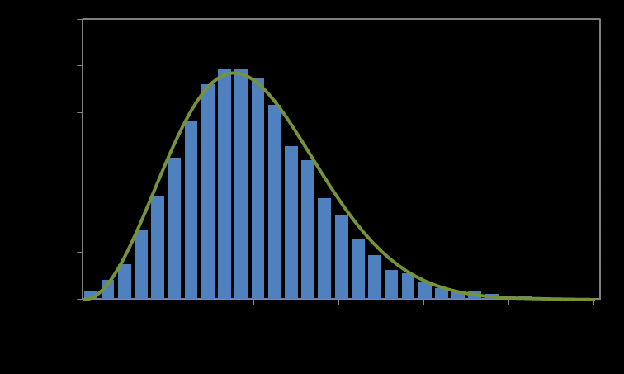

**BOX: Histogram activity**

Assume that you are monitoring the time you take to reach school every day for the next 30 days. When you review your results at the end of the month, it may not be uniform every day. It fluctuates between days. On a sunny day, you may be tired of walking and reached a little late. On a rainy day, perhaps you might have taken a taxi and arrived earlier. However, most of the time, you might have taken some time which remains almost constant, frequently. When you plot your results with time-ranges on the x-axis and the frequency on the y-axis, then you will get a histogram with a bell curve. A histogram of all the car’s speeds crossing your street will also look similar. Sometimes you see a high or low speed car, but mostly you witness most of the cars going in a particular speed range. This “most frequent value” corresponds to the peak in the graph.

**END OF BOX**

When scientists try to plot the histogram of molecular speed, they obtained a similar bell curve. The bell curve says that most of the molecules are crowded to a particular range of velocities, whereas a few of them lie either with zero or at some extreme velocities. In general, scientists have a technical definition of the average velocity of the molecules (given by the root mean square of the varying molecular velocities), which lies close to the bell curve’s peak. The value can be calculated analytically using the relation given below,

$v=\sqrt{\frac{3RT}{M}}$

(Here, $R$ is the universal gas constant: 8.31432 J⋅K−1⋅mol−1, is the temperature of molecular medium in Kelvin, and $M$ is the molar mass of the molecule: kg/mol).

In the graph, we have shown the bell curve for Nitrogen (N2, 28 g/mol) and Helium (He, 4 g/mol) molecules at 800 K. As you can see, the heavier molecule has low molecular velocity and vice versa for the lighter molecule.

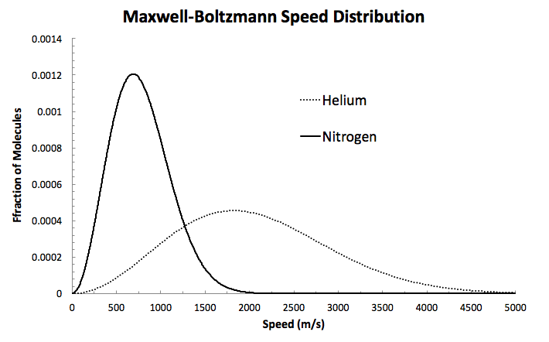

Now, let us look at the constituents of our atmosphere. We have 78% nitrogen, 21% oxygen and 1% other gases. Using the above relation at ambient temperature of 298 K (25 Celsius), we will get back the average velocity of the molecule as 0.5152 km/s (N2), and 0.6818 km/s (O2). (This is more than 20,000 km/hr!) In general, the largest velocity in the distribution graph will lie close to 4-6 times the average velocity as predicted in the experiments.

Now let us revisit the escape velocity of our planet Earth. The escape velocity can be calculated using the analytical relation given below,

$v_{e}=\sqrt{\frac{2GM}{R}}$

(Here, $G$ is the gravitational constant: m3kg-1s-2, is the mass of the planet in kg, $R$ is the radius of the planet:in m). While substituting the values for Earth ( $M=5.972×{10}^{24}$ kg, $R=6371$ km) and Moon ( $M=7.342×{10}^{22}$ kg, $R=1737.4$ km), we calculate the escape velocity of Earth and Moon as 11.2 km/s and 2.38 km/s, respectively. So you can see that it is not easy to launch yourself into space by just running very fast!

Now, if we consider the molecular speed of nitrogen and oxygen (essential for living), the values (about half a km/s) are considerably lower than the escape velocity (more than 2 km/s) of the Moon. However, remember, these are the average velocities which lie close to the peak of the velocity distribution curve (bell curve). There are many other molecules, which are travelling at higher velocities. Hence, we need to multiply the average velocity by 6 to include even the molecules possessing the highest velocity. By doing so, we get velocities (3-4 km/s) which are higher than the escape velocity of the Moon (2.38 km/s). Hence, if these molecules are somehow produced inside the planet or captured in the planet, they will simply escape the surface of the Moon. This is the primary reason why we do not see an atmosphere in the Moon. Nevertheless, is it the only reason? We will discuss more in the upcoming articles in later issues of *JM*.