Puzzles to Puzzle You
1. Magic Belt
A magic rectangular belt always shrinks its length to 1/2 and width to 1/3 whenever its owner wishes something.
After three such wishes, its surface is now 4 cm².
What was the original length, if the original width was 9 cm?
Ans: Let the length be L and its width W. After the first wish, they are L/2 and W/3. After the second, it was (L/2)/2=L/4 and (W/3)/3=W/9. After the third wish, it was (L/4)/2=L/8 and (W/9)/3=W/27. The area of this thrice-decreased belt is given to be 4. So (L/8)x(W/27)=4, or LxW=4x8x27. But we know that W=9. So L=4x8x27/W=4x8x27/9=96 cm.
2. A Hole New Board Game
How can I cut the board (shown in figure) into only two pieces so that they will fill inside the hole exactly?
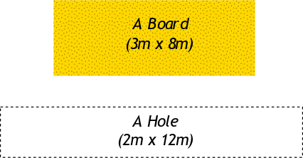
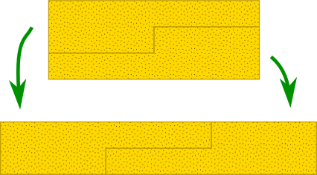

Ans: See figure on the right.
3. Desert transport
An important person has to be urgently taken across the desert. There is no petrol station in the desert and the car can only fill enough petrol to reach half way across the desert. There are no cans to carry extra petrol, but there are other identical cars that can transfer their petrol into one another. So the car
carrying the important person can borrow petrol from the petrol tanks of the other car, which can then be left behind to be picked up later.
How can we get this important person across the desert?
Ans: Let us imagine that we are the important person! Our car, when filled with petrol, can reach half way before it runs out of petrol. So it needs an additional full tank to reach the other end. So we need a car (or cars) to donate a full tank of petrol on the way.
If we had only one additional car, and it had to donate its full tank, it could not even travel from the starting point. But at the starting point our car is already full and cannot accept more petrol. So clearly we need more than one additional car.
What about two? Let the total distance to be travelled be L and the fuel a car can carry be F. So F fuel will get you half way across, that is, L/2. We now want two cars to donate the remaining required F fuel. They together start with 2F fuel (F each), and so they have to donate half their fuel. Suppose they travel a distance where half their fuel is over so that they have F/2 left to donate. Our car has also got only F/2 fuel left. But it cannot accept more than F/2 fuel (say from one other car) before its tank becomes full. So the other car has to travel longer until some of this fuel is used up so that it can donate its fuel. But what happens? This car should donate F/2, but it has only F/2 fuel left in its tank at that point. So the moment it starts travelling, it uses up some of its fuel and so it cannot donate F/2 to our car.
Clearly two cars are not enough. We need at least three other cars to accompany our car for a successful journey. How does this work? Three cars have total 3F fuel and need to donate F of it to our car. So they need to donate F/3 fuel each to our car and will be left with 2F fuel among themselves. On 2F fuel, you can travel a distance L. If this is divided uniformly among the cars, each can travel L/3. But as we saw earlier, they cannot all travel the same distance, because, once one car has donated its fuel, our car will have a full tank and the others will not be able to donate their fuel at the same time. So we have to be smarter than that.
Consider the point half-way to L/3, that is, a distance L/6, when each car (including ours) has used one third (F/3) of its fuel. Now car-1 stops and donates 2/3 of its fuel: 1/3 to our car (so it becomes full) and 1/3 to car-3 (so it becomes full as well). Now we have our full car, car-1 empty (and abandoned), car-2 2/3 full, and car-3 full. Let us travel another L/6. At the end of this, car-3 and our car have 2/3F each, and car-2 is 1/3 full. Let car-2 donate its fuel to us, so we have a full tank, and it is abandoned. This leaves car-3 (with 2/3F) and our car (full tank) to continue the journey. Again let us travel L/6 and use up 1/3 of our fuel. Now car-3 has 1/3F and we have 2/3F. Now it is the turn of car-3 to donate its fuel to us so that it stops, and we are full up. But, wait a minute. Where are we? We have travelled (L/6+L/6+L/6)=L/2 distance, so we are exactly at the half-way point, and with a full tank! We just use this entire tank to reach the other end!!
4. Double Hearts Ratio
Which is bigger: the total area of yellow or the total area of red?
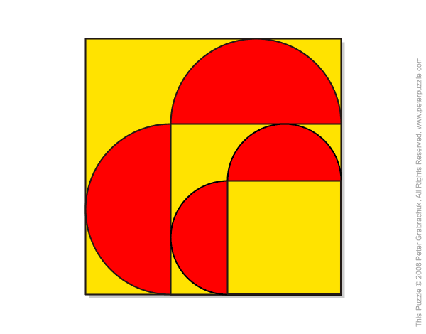

Ans: We need to calculate the areas of the square using Area=length squared, and the area of circles using the formula, Area = pi r² , where r is the radius of the circle and pi is 22/7 (approx).
The red area has two semi-circles of radius 3, and two of radius 2. So the total red area = area of the large and small circle.
Area of big red circle = π×(3)² = 28.27
Area of small red circle = π×(2)² = 12.57
So the total red area is A (red) = 28.27 + 12.57 = 40.84.
To find the yellow area, we need to subtract the red area from the area of the big square. There are 9 small squares in the large square, so its area is 9x9=81 units. So the yellow area is A(yellow) = 81 - 40.84 = 40.16. So the red area is actually bigger than the yellow area!
From mathsisfun.com

