Why doesn’t the lung collapse during breathing?
Susy Varughese, Indian Institute of Technology, Madras

The theme of this issue of Jantar Mantar is on soaps, surface tension etc. You would have already understood from other articles in this issue that detergents and shampoos have surfactants or “surface active agents” which reduces the surface tension of water. When we hear about surfactants, mostly we think about man-made or synthetic materials. Did you know that there are many surfactants found in nature too?

In fact, some of the natural surfactants have very important roles in our life. For example, did you know how our lungs prevent themselves from collapsing after we exhale the CO₂ each time? Apparently a natural surfactant available in the lungs known as “pulmonary surfactant” keeps the lung from collapsing and also keeps it in shape.

Lung surfactant is a complex substance containing phospholipids and a number of proteins. The general function of all surfactants is to reduce the surface tension. Surface tension is measured in units of Newton/meter (N/m). For example, water has a surface tension of 70 milliNewton/meter (mN/m). In the presence of lung surfactant or the pulmonary surfactant it can drop to 2mN/m.

To understand the role of lung surfactant a bit more, let us take a look at the simple anatomy of our lungs and how this surfactant works in our lungs.

Human lung consist of lots of branches which ends up in small, spherical baloons known as “alveoli” (see pictures 1 and 2). Alveoli can be compared to air bubbles in water, as the alveoli are wet and surround a central air space. Oxygen diffuses from the alveoli into the blood capillaries through a very thin layer of cells and CO₂ diffuses back into the alveoli back from the blood capillaries through the thin layer of these spherical baloons. The alveoli cells produce the lung surfactants which reduce the surface tension of the moisture present in the lungs. The presence of water or moisture is very important in the lungs for the dissolution of oxygen.
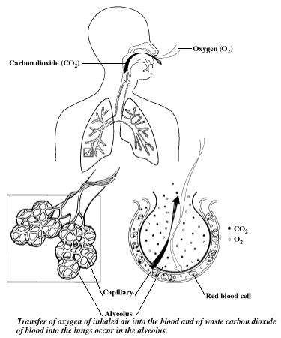
Picture 1

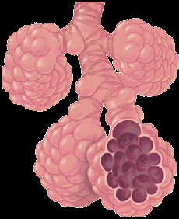
Picture 2 : Alveoli inside the lungs

Now let us take a look at how these lung surfactants keep the lung from collapsing. The pressure within a spherical structure with surface tension, such as the alveolus, is inversely proportional to the radius of the sphere. P = 4T/r for a sphere with two liquid-gas interfaces, like a soap bubble, and P=2T/r for a sphere with one liquid-gas interface, like an alveolus: P=pressure, T=surface tension, and r=radius. That is, at a constant surface tension, small alveoli will generate bigger pressures within them than will large alveoli. Smaller alveoli would therefore be expected to empty into larger alveoli as lung volume decreases. This does not occur, because surfactant reduces surface tension, more at lower volumes and less at higher volumes, leading to alveolar stability and reducing the chances of alveolar and lung collapse (See picture 3). The surface tension acts at the air-water interface and tends to make the bubble smaller (by decreasing the surface area of the interface).

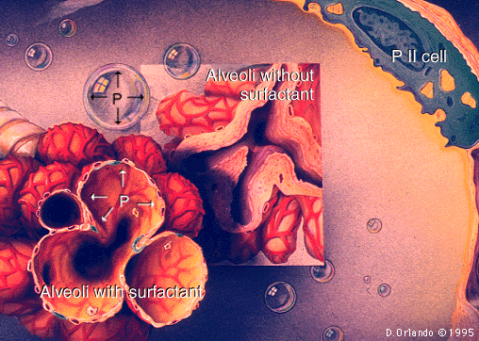
Picture 3. Alveoli with and without the pulmonary surfactant

